**AIM**

To model a simple HTML file describing your hometown (demonstrate the use of different tags).

**Program Code**

<html>

<head>

<link rel="stylesheet" href="style.css">

<title>

Koratty

</title>

</head>

<body bgcolor="#FEF8DD">

<div style="background-color:lightblue" align="left">

<img src="/home/stud/Anex/Logo.png" alt="logo" width="100" height="100">

<h1 align="center">KORATTY</h1>

<ul>

<li><p><a href="html_images.asp">HTML Images</a></p></li>

<li><p><a href="/css/default.asp">CSS Tutorial</a></p></li>

<li><p><a href="html_images.asp">HTML Images</a></p></li>

<li><p><a href="/css/default.asp">CSS Tutorial</a></p></li>

</ul>

</div>

<div align="center">

<img src="/home/stud/Anex/church.jpg" alt="logo" width="200" height="200">

<img src="/home/stud/Anex/Koratty.JPG" alt="logo">

<img src="/home/stud/Anex/map.svg.png" alt="logo" width="200" height="200">

<img src="/home/stud/Anex/infopark.jpg" alt="logo" width="200" height="200">

<img src="/home/stud/Anex/Muthy.jpg" alt="logo" width="200" height="200">

</div>

<h1><u>Koratty</u></h1>

<font size=3>From Wikipedia, the free MediaOne-</font>

<p>Koratty is a census town in Thrissur district in the Indian state of Kerala. It is a main centre of Marian Pilgrimage.</p>

<div>

<p><a href="html_images.asp">HTML Images</a></p>

<p><a href="/css/default.asp">CSS Tutorial</a></p>

<h3><u>Demographics</u></h3>

<p>As of 2011 India census,[1] Koratty had a population of 17,618. Males constitute 49% of the population and females 51%. Koratty has an average literacy rate of 96.72%, higher than the national average of 74%: male literacy is 97.94%, and female literacy is 95.58%. In Koratty, 9% of the population is under 6 years of age.</p>

<h3><u>Tourism & Pilgrimage Travel</u></h3>

<p>Korattymuthy - Our Lady with Poovan Bananas</p>

<p>Korattymuthy - Shrine of Our Lady with Poovan Bananas (Poovankula Matha.) Koratty is one of the biggest Marian/Christian/Catholic pilgrimage travel destination of Kerala in India. Korattymuthy Shrine is a Pilgrimage centre in Kerala. It is also known as the Lourdes of Kerala. Korattymuthy- Our Lady with Poovan Bananas[2] is the well known name for Holy Mary or Mother Mary here. Devotees from all over the world visit Koratty annually. Every year the Feast of Koratty Muthy will commence on 1st Sunday after 10 October. The flag for the feast will be hosted on the previous Wednesday.</p>

<h3><u>Industry</u></h3>

<p>Koratty is also famous for its industrial units. Vaigai Thread Processors Ltd. (formerly J&P Coats, Jamuna Threads & Madura Coats and Coats Viella (I) Ltd. etc.). Another major industry is in Public Sector under the control of Government of India - Government of India Press, Koratty (GIPK). It is the one and only Indian Government controlled press in Kerala. Earlier it has been proposed to convert it into a security press for the printing of Stamp Papers and Postal Stamps etc. On modernization drive, lately Govt of India UM has decided to shut down its operation due to non-feasibility. the Other industries like Carborandum Universal, Kerala Chemicals & Proteins Ltd (KCPL) are also located here.</p>

<p>Sri. Panampilly Govinda Menon, former Chief Minister of Kerala and former Central Cabinet Minister for Railways, was the frontrunner in bringing these industries to Koratty and nearby areas as he was a native of Kathikudam near Koratty.</p>

<h3><u>Kinfra Park</u></h3>

<p>Another industrial area situated in Koratty is Kinfra Small Industries Promotion Park (KSIPP),[3] lot of small scale industrial units are situated inside the park. It is located 0.5 km east of Koratty Jn. on Konoor Rd. A new venture for manufacturing and quality control of Ayurvedic medicines promoted jointly by Kinfra & and major Ayurvedic Medicine manufactures (Pankajakasthuri, The Arya Vaidya Pharmacy, Vaidyaratnam Oushadasala, Nagarjuna, Sitaram, Sreedhareeyam, S.D. Pharmacy, Kandamkulathy, Dhanwantari and Kerala Ayurveda Pharmacy) namely Confederation of Ayurvedic Renaissance-Keralam Pvt Ltd (CARe-Keralam),[4] is also upcoming in 10 acres (40,000 m2) of land near Koratty Kinfra Park.</p>

<h3><u>Infopark Thrissur</u></h3>

<p>An IT park is started functioning in this town from 10 October 2009 -known as Infopark Thrissur. More than 30 companies[5] are functioning in this park. Infopark Thrissur is considered to provide direct employment to 3,000 people and may boost the real estate sector in this area. The new upcoming campus consisting of a multistory building, with more than one lakh square feet built up area got Special economic zone (SEZ) status from government of India in July 2014.[6] and will be known as 'INFOPARK -Koratty'</p>

<h3><u>Educational Instituitions</u></h3>

<p>Several educational institutions are located in Koratty Town and nearby areas. Mar Augustine Memorial Higher Secondary School (MAMHS), Little Flower Convent Higher Secondary School (LFCGHSS), Government Poly Technic College (GPC), Naipunnya Institute of Management and Information Technology, Perpetual Succour Higher Secondary School (PSHSS), Thirumudikkunnu are the major institutions of Koratty.</p>

<h3><u>References</u></h3>

<ol>

<li><p><a href="html_images.asp">HTML Images</a></p></li>

<li><p><a href="/css/default.asp">CSS Tutorial</a></p></li>

<li><p><a href="html_images.asp">HTML Images</a></p></li>

<li><p><a href="/css/default.asp">CSS Tutorial</a></p></li>

<li><p><a href="html_images.asp">HTML Images</a></p></li>

</ol>

<h3><u>External Links</u></h3>

<ul>

<li><p><a href="html_images.asp">HTML Images</a></p></li>

<li><p><a href="/css/default.asp">CSS Tutorial</a></p></li>

<li><p><a href="html_images.asp">HTML Images</a></p></li>

<li><p><a href="/css/default.asp">CSS Tutorial</a></p></li>

<li><p><a href="html_images.asp">HTML Images</a></p></li>

</ul>

</body>

</html>

**Output**

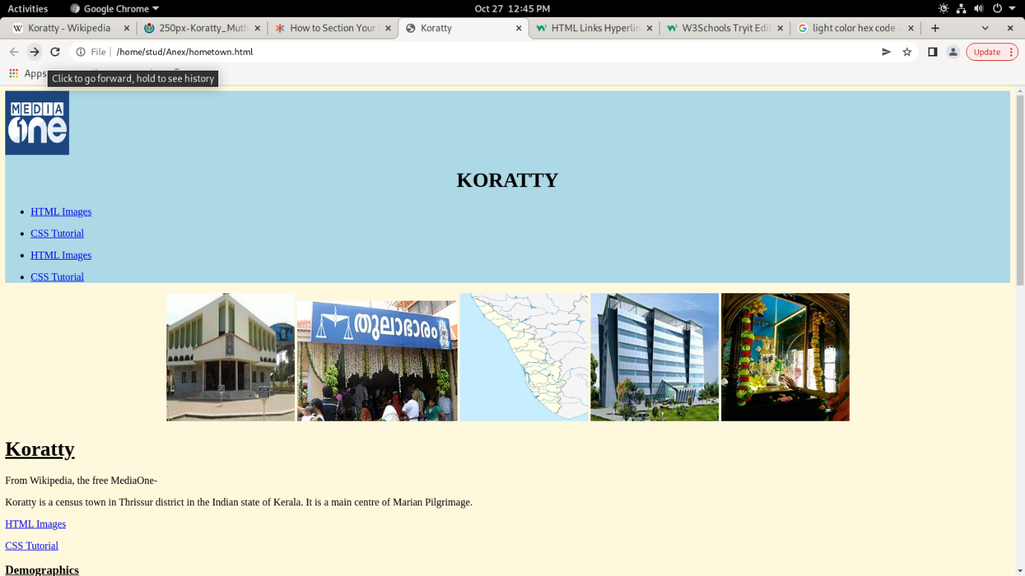

**AIM**

Create a webpage for displaying your biodata which contains images, tables, and also link within a page.

**Program Code**

**BIO-DATA.html**

<html>

<head>

<title>

</title>

<style>

.myDiv {

   width: 700px;

   height: 700px;

   position: absolute;

   top: 20%;

   left: 30%;

   background-color: lightblue;

   text-align: center;

   border-style: dotted;

}

</style>

</head>

<body background="/home/stud/Anex/blue.webp">

<div class="myDiv">

<br><br><h1><u>BIO&nbsp;DATA</u></h1><br>

<img src="dhoni.jpeg" alt="profile pic" width="100" height="100" style="vertical-align:top">

<h2>NAME :&nbsp;&nbsp;&nbsp;ANEX PAULY</h3>

<h3>PERSONAL DETAILS: &nbsp;&nbsp;<a href="/home/stud/Anex/personal.html">Click Here</a></h3></li>

<h3>ACADEMIC DETAILS: &nbsp;&nbsp;<a href="/home/stud/Anex/academic.html">Click Here</a></h3></li>

</div>

</body>

</html>

**Personal details.html**

<html>

<head>

<title>

</title>

<style>

.myDiv {

   width: 700px;

   height: 700px;

   position: absolute;

   top: 20%;

   left: 30%;

   background-color: lightblue;

   text-align: center;

   border-style: dotted;

}

</style>

</head>

<body background="/home/stud/Anex/blue.webp">

<div class="myDiv">

<br><br><h1><u>PERSONAL DETAILS</u></h1><br>

<img src="dhoni.jpeg" alt="profile pic" width="250" height="250" style="vertical-align:top">

<h3><u>NAME :</u>&nbsp;&nbsp;&nbsp;ANEX PAULY</h3>

<h3><u>FATHER'S NAME :</u>&nbsp;&nbsp;&nbsp;PAULY GEORGE</h3>

<h3><u>MOTHER'S NAME :</u>&nbsp;&nbsp;&nbsp;SIJI PAULY</h3>

<h3><u>DOB :</u>&nbsp;&nbsp;&nbsp;18/03/1998</h3>

<h3><u>PLACE :</u>&nbsp;&nbsp;&nbsp;KORATTY</h3>

<h3><u>ADDRESS :</u>&nbsp;&nbsp;&nbsp;CHALISSERY (H) KORATTY P.O KATTAPPURAM</h3>

<h3><u>BLOOD GROUP :</u>&nbsp;&nbsp;&nbsp;O+ve</h3>

</div>

</body>

</html>

**Academic details.html**

<html>

<head>

<title>

</title>

<style>

th, td {

  padding-top: 10px;

  padding-bottom: 20px;

  padding-left: 30px;

  padding-right: 40px;

  }

table, th, td {

  border: 1px solid black;

  border-collapse: collapse;

  }

 tr, td, th {

  background-color: #D6EEEE;

  }

.myDiv {

   width: 700px;

   height: 700px;

   position: absolute;

   top: 20%;

   left: 30%;

   background-color: lightblue;

   text-align: center;

   border-style: dotted;

}

</style>

</head>

<body background="/home/stud/Anex/blue.webp">

<div class="myDiv">

<br><br><h1><u>ACADEMIC DETAILS</u></h1><br>

<table style="height:50%" align="center" border="1">

<tr>

<th>

Qualification

</th>

<th cellspacing="5">

Institution

</th>

<th>

Marks Obtained

</th>

</tr>

<tr>

<th>

10th

</th>

<td>

Little Flower Public School

</td>

<td>

80%

</td>

</tr>

<tr>

<th>

+2

</th>

<td>

MAMHSS

</td>

<td>

85%

</td>

</tr>

<tr>

<th>

Degree - Bsc. CS

</th>

<td>

Naipunnya

</td>

<td>

72%

</td>

</tr>

</table>

</div>

</body>

</html>

**Output**

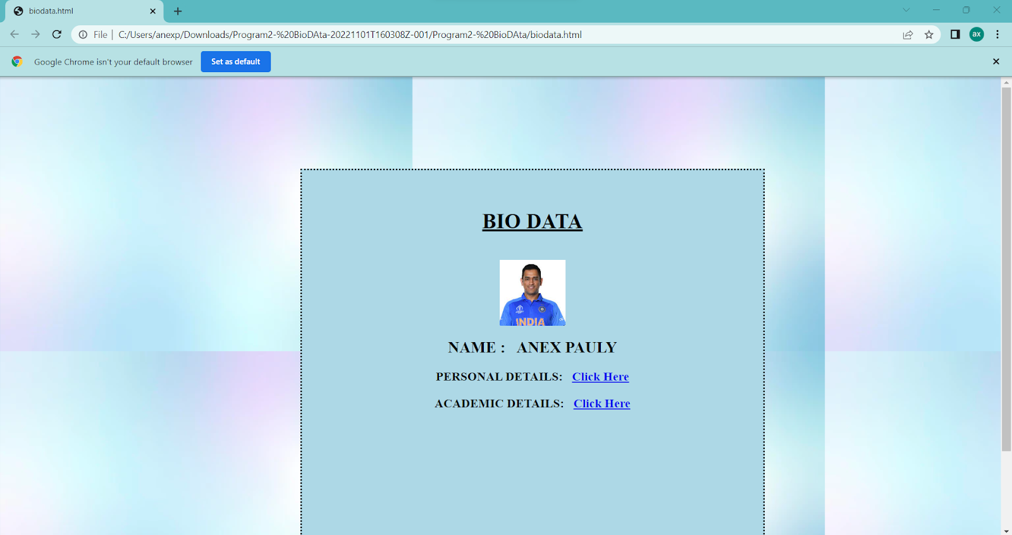

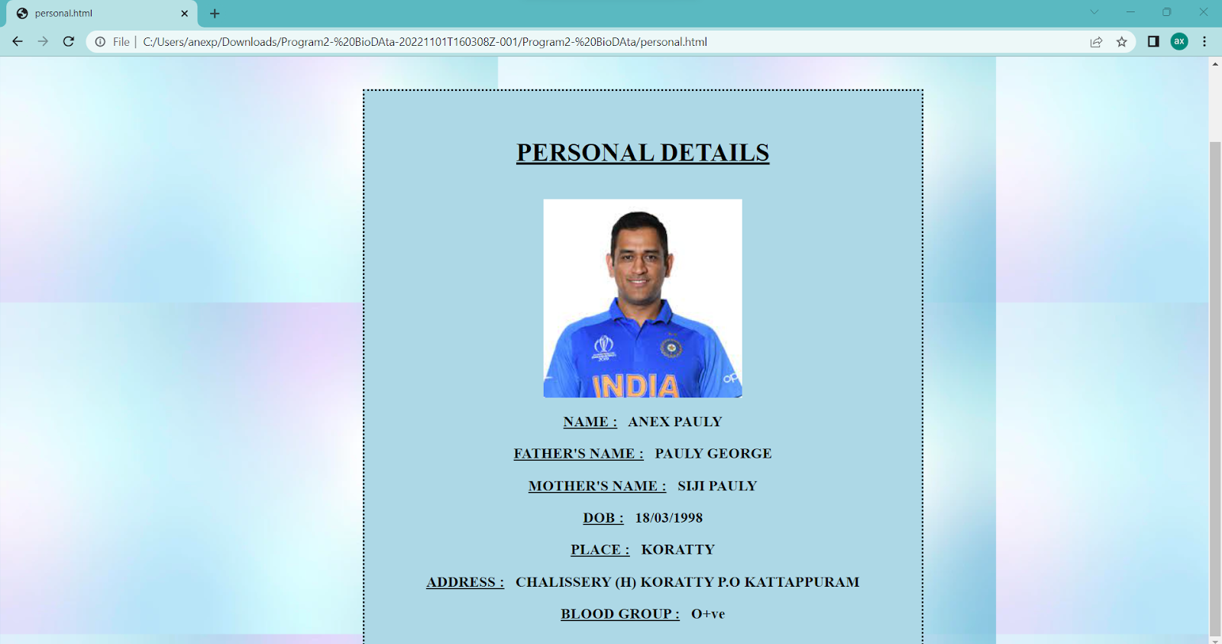

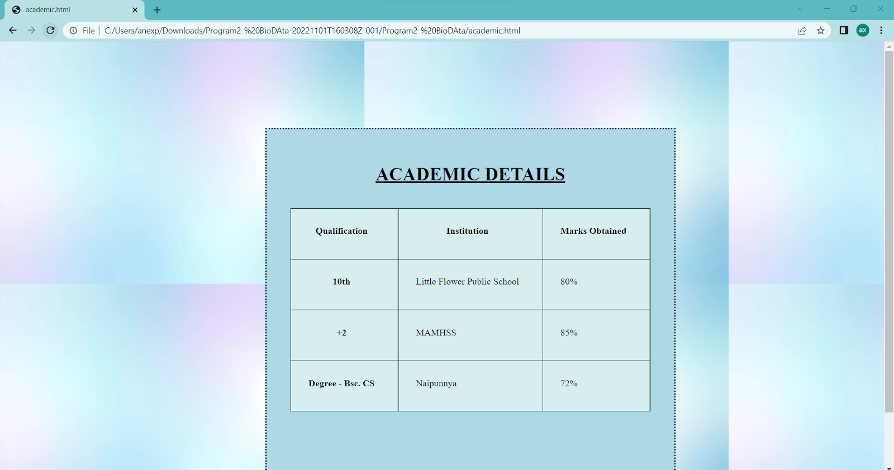

**AIM**

Design an application form for MCA course in Fisat using HTML.

**Program Code**

<html>

<head>

<title>

</title>

<style>

.myDiv {

   width: 700px;

   height: 2000px;

   position: absolute;

   top: 20%;

   left: 30%;

   background-color: #fefbd9;

   text-align: center;

   border-style: groove;

   border-color: #92a8d1;

}

</style>

</head>

<body background="C:\Users\anexp\Downloads\pgrm3-form-20221103T185956Z-001\pgrm3-form\back.jpg">

<div class="myDiv">

<img src="logo2.jpg" alt="profile pic" width="100" height="100" style="horizontal-align:left">

<img src="logo1.png" alt="profile pic" width="250" height="90" style="horizontal-align:left">

<br><br><h1><u>MCA&nbsp;&nbsp;REGISTRATION&nbsp;&nbsp;-&nbsp;&nbsp;2022</u></h1><br>

<form method="post">

Name: <input type="text" placeholder="Name of the student" name="name" required><br><br><br>

Gender: Male <input type="radio" placeholder="Gender of the student" name="Gend" required>

Female <input type="radio" placeholder="Gender of the student" name="Gend" required><br><br><br>

Date of Birth: <input type="text" placeholder="DOB of student" name="dob" required><br><br><br>

Mobile Number: <input type="text" placeholder="Phone no of the student" name="mob" required><br><br><br>

Parent mobile Number: <input type="text" placeholder="Phone no of the Parent" name="mob2" required><br><br><br>

Email Id: <input type="email" pattern=".+@gmail\.com" placeholder="Email id of the student" name="email" required><br><br><br>

<u>Academic Details</u><br><br>

Xth Details<br><br>

Board of Exam: <input type="text" placeholder="DOB of student" name="dob" required><br><br><br>

School name & Place: <input type="text" placeholder="Phone no of the student" name="mob" required><br><br><br>

Registration Number: <input type="text" placeholder="DOB of student" name="dob" required><br><br><br>

Year of passing:

<select>

<option value="2019">2019</option>

<option value="2020">2020</option>

<option value="2021">2021</option>

<option value="2022">2022</option>

</select><br><br><br>

<button type="submit" value="Submit1">Submit</button><br><br><br><br>

XIIth Details<br><br>

Board of Exam: <input type="text" placeholder="DOB of student" name="dob" required><br><br><br>

School name & Place: <input type="text" placeholder="Phone no of the student" name="mob" required><br><br><br>

Registration Number: <input type="text" placeholder="DOB of student" name="dob" required><br><br><br>

Year of passing:

<select>

<option value="2019">2019</option>

<option value="2020">2020</option>

<option value="2021">2021</option>

<option value="2022">2022</option>

</select><br><br><br>

<button type="submit" value="Submit2">Submit</button><br><br><br><br>

Degree Details<br><br>

Board of Exam: <input type="text" placeholder="DOB of student" name="dob" required><br><br><br>

School name & Place: <input type="text" placeholder="Phone no of the student" name="mob" required><br><br><br>

Registration Number: <input type="text" placeholder="DOB of student" name="dob" required><br><br><br>

Year of passing:

<select>

<option value="2019">2019</option>

<option value="2020">2020</option>

<option value="2021">2021</option>

<option value="2022">2022</option>

</select><br><br><br>

<button type="submit" value="Submit2">Submit</button><br><br><br><br>

<button type="submit" style="height:50px; width:100px" value="Submit">Submit</button>

<button type="reset" value="Reset" style="height:50px; width:100px">Reset</button>

</form>

</div>

</body>

</html>

**Output**

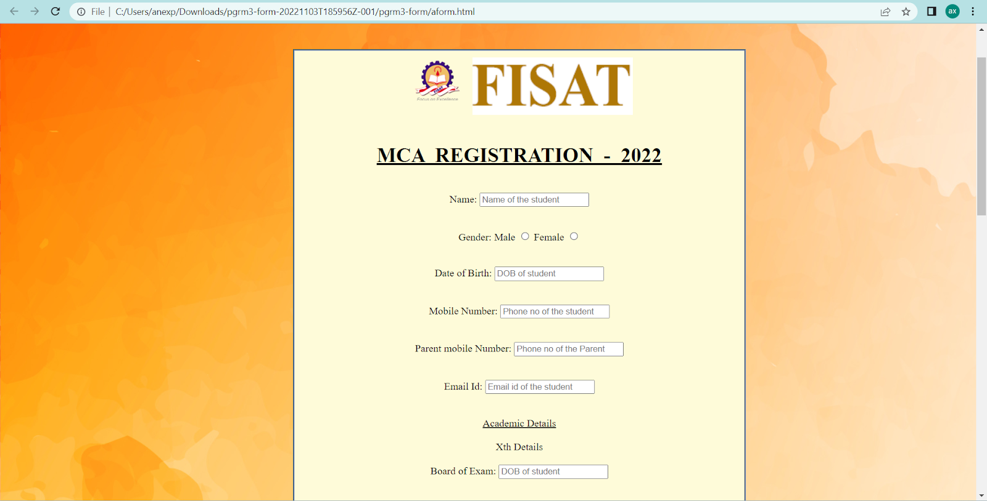

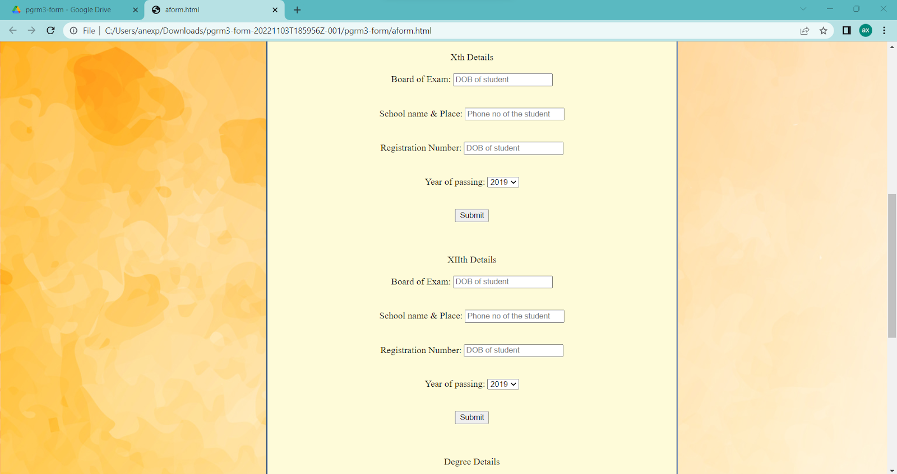

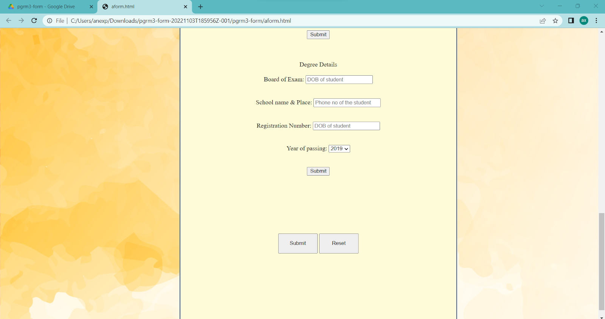

**AIM**

Create a HTML page with different types of frames such as floating frame, navigation frame & mixed frame.

**Program Code**

**Main Html**

<html>

<head>

<title>

</title>

<style>

.myDiv{

width: 700px;

   height: 700px;

   position: absolute;

   top: 20%;

   left: 30%;

   background-color: lightblue;

   text-align: center;

   border-style: dotted;

}

</style>

</head>

<body background="C:\Users\anexp\Downloads\pgrm4-FRames-20221107T164259Z-001\pgrm4-FRames\5570863.jpg">

<div class="myDiv">

<br><br><h1><u>FRAMES</u></h1><br>

<h3>Navigation Frame: &nbsp;&nbsp;<a href="C:\Users\anexp\Downloads\pgrm4-FRames-20221107T164259Z-001\pgrm4-FRames\Nested.html">Click Here</a></h3>

<h3>Mixed Frame: &nbsp;&nbsp;<a href="C:\Users\anexp\Downloads\pgrm4-FRames-20221107T164259Z-001\pgrm4-FRames\mixedframe.html">Click Here</a></h3>

<h3>iFrame: &nbsp;&nbsp;<a href="C:\Users\anexp\Downloads\pgrm4-FRames-20221107T164259Z-001\pgrm4-FRames\iframe.html">Click Here</a></h3>

</div>

</body>

</html>

**Nested html**

<html>

<head>

<title>

</title>

<style>

frame.Frame1 {

border-style: outset;

border-color: lightblue;

background-color: lightblue;

}

frame.Frame2 {

border-style: outset;

border-color: lightblue;

background-color: lightyellow;

}

frame.Frame3 {

border-style: outset;

border-color: lightblue;

}

</style>

</head>

<frameset frameBorder="0" cols="150,*">

<frame class="Frame1" src="navigation.html" scrolling="no">

<frameset frameBorder="0" rows="20%,80%">

<frame class="Frame2" src="intro.html" scrolling="no">

<frame name="MainF" class="Frame3" src="" scrolling="no">

</frameset>

</frameset>

</html>

**Navigation Html**

<html>

<head>

<title>

Navigation Bar

</title>

</head>

<body>

<center>

<h2><u>Navigation Links</u></h2>

<br>

<br>

<br>

<br>

<br>

<br>

<h3><a href="note1.html" target="MainF">First Page</a></h3><br><br>

<h3><a href="note2.html" target="MainF">Second Page</a></h3><br>

</center>

</body>

</html>

**Intro html**

<html>

<head>

<title>

</title>

<style>

img.Image2 {

position: absolute;

top: 8px;

right: 16px

}

h2{

font-family: "Lucida Console";

}

</style>

</head>

<body>

<img src="C:\Users\anexp\Downloads\pgrm4-FRames-20221107T164259Z-001\pgrm4-FRames\white.png" height="40px" width="40px">

<h2 align="center"><u>NOTEBOOK</u></h2>

<img class="Image2" src="C:\Users\anexp\Downloads\pgrm4-FRames-20221107T164259Z-001\pgrm4-FRames\logo.svg" height="70px" width="120px">

</body>

</html>

**Note1 html**

<html>

<head>

<title>

</title>

<style>

h2{

font-family: "Lucida Console";

}

</style>

</head>

<body>

<h3><p>Classmate is an Indian brand of student stationery products. ITC Limited (formerly Indian Tobacco Company) launched its Classmate brand in 2003 with the notebooks category. Subsequently, Classmate added pens, pencils, mechanical pencils and geometry boxes to its portfolio. It uses eco-friendly and elemental chlorine-free paper.</p>

<p>Classmate launched a program called Classmate Ideas for India challenge.This was a part of the company's centenary initiative.The nationwide program would invite ideas of the youth who have the potential to transform India. Classmate Ideas for India challenge plans to reach out to 2.5 million students across 30 cities, 500 schools and 200 colleges across the country.The CII-ITC Centre of Excellence for Sustainable Development, WWF India, the Tony Blair Faith Foundation, Janaagraha and the Akshaya Patra Foundation among others are the program partners for the event.The program will encourage the finalists with an internship with relevant program partners, besides cash prizes and other rewards. Additionally, the top five winners would be sent to a one-week international study tour.</p>

<p>

This first took off in 2015. Classmate launched a new initiative - Classmate Art Academy to promote its latest range of art products. The certificate training program brought together art teachers from top schools of New Delhi under one roof, to provide them with a platform to learn new skills. The property was executed by Victor Tango. Classmate recognizes the advantages of nurturing artistic pursuits in the all-round development of a child and aims at providing them with the right tools. The exciting range of Classmate Colour Crew products consist of Sketch Pens, Wax Crayons and Oil Pastels, designed to ensure that the uniqueness of each child shines through in the most colourful way.

</p>

</h3>

</body>

</html>

**Note2 Html**

<html>

<head>

<title>

</title>

<style>

h2{

font-family: "Lucida Console";

}

</style>

</head>

<body>

<h3><u>Different Types</u>

<ul>

<li>Ruled Book</li>

<li>Unruled Book</li>

<li>Ruled Book</li>

<li>Unruled Book</li>

<li>Ruled Book</li>

<li>Unruled Book</li>

<li>Ruled Book</li>

<li>Unruled Book</li>

<li>Ruled Book</li>

<li>Unruled Book</li>

<li>Ruled Book</li>

<li>Unruled Book</li>

<li>Ruled Book</li>

<li>Ruled Book</li>

<li>Unruled Book</li>

<li>Ruled Book</li>

</ul>

</h3>

</body>

</html>

**Mixedframe html**

<html>

<head>

<title>

</title>

<style>

frame.Frame1 {

border-style: outset;

border-color: lightblue;

}

frame.Frame2 {

border-style: outset;

border-color: lightblue;

background-color: lightgreen;

}

frame.Frame3 {

border-style: outset;

border-color: lightblue;

}

</style>

</head>

<frameset frameBorder="0" cols="150,*">

<frame class="Frame1" src="note2.html" scrolling="no">

<frameset frameBorder="0" rows="20%,80%">

<frame class="Frame2" src="intro.html" scrolling="no">

<frame class="Frame3" src="note1.html" scrolling="no">

</frameset>

</frameset>

</html>

**Floating Frame.html**

<html>

<head>

<title>

Navigation Bar

</title>

<style>

iframe.Frame1 {

border-style: outset;

border-color: lightblue;

background-color: lightblue;

}

</style>

</head>

<body>

<center>

<h2><u>Floating Frame</u></h2>

<br>

<br>

<br>

<iframe class="Frame1" src="note1.html" height="50%" width="50%">

</iframe>

</body>

</html>

**Output**

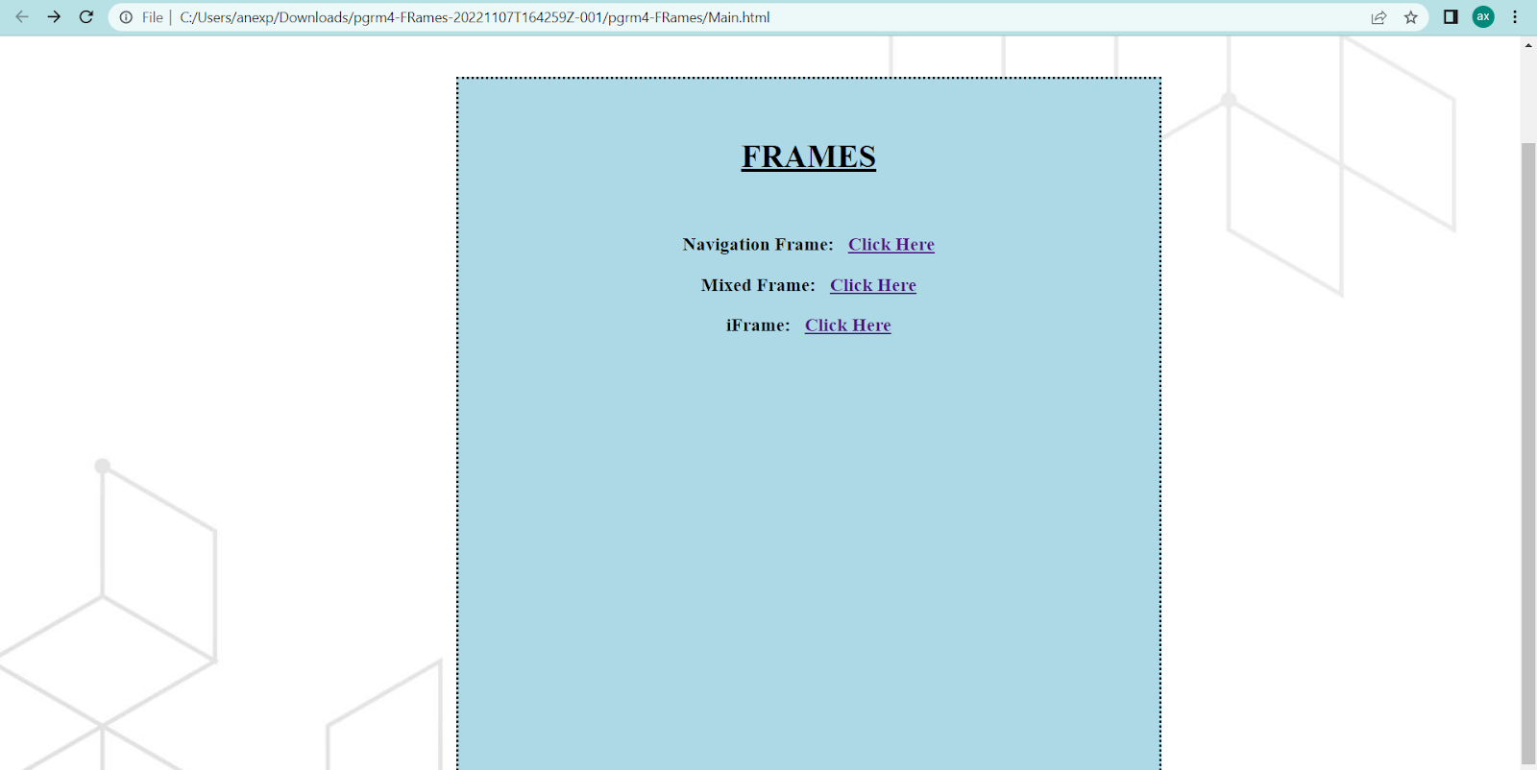

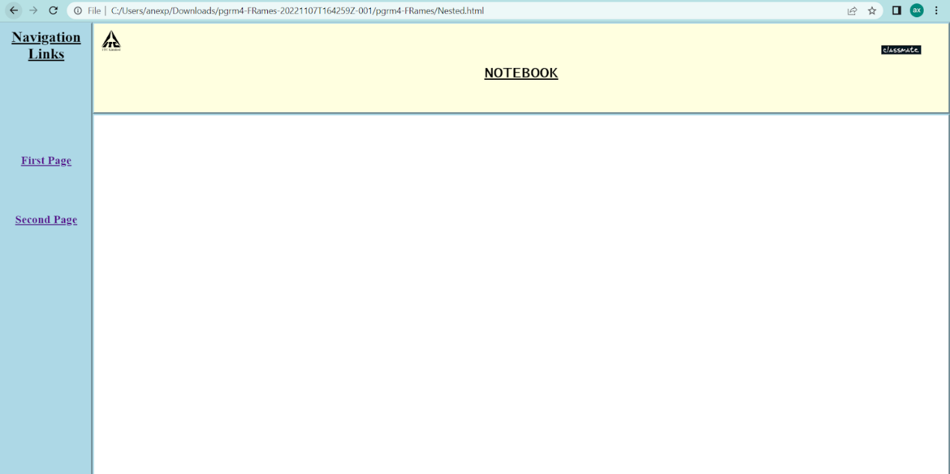

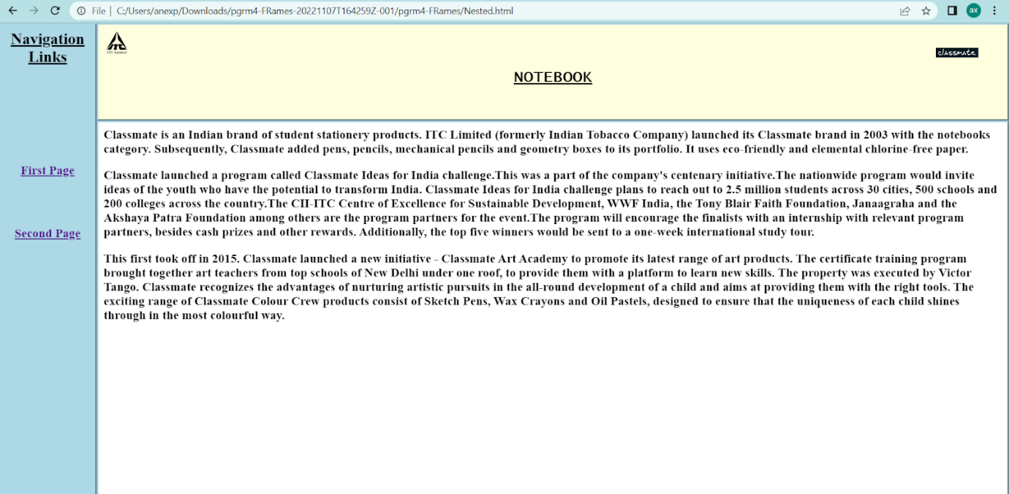

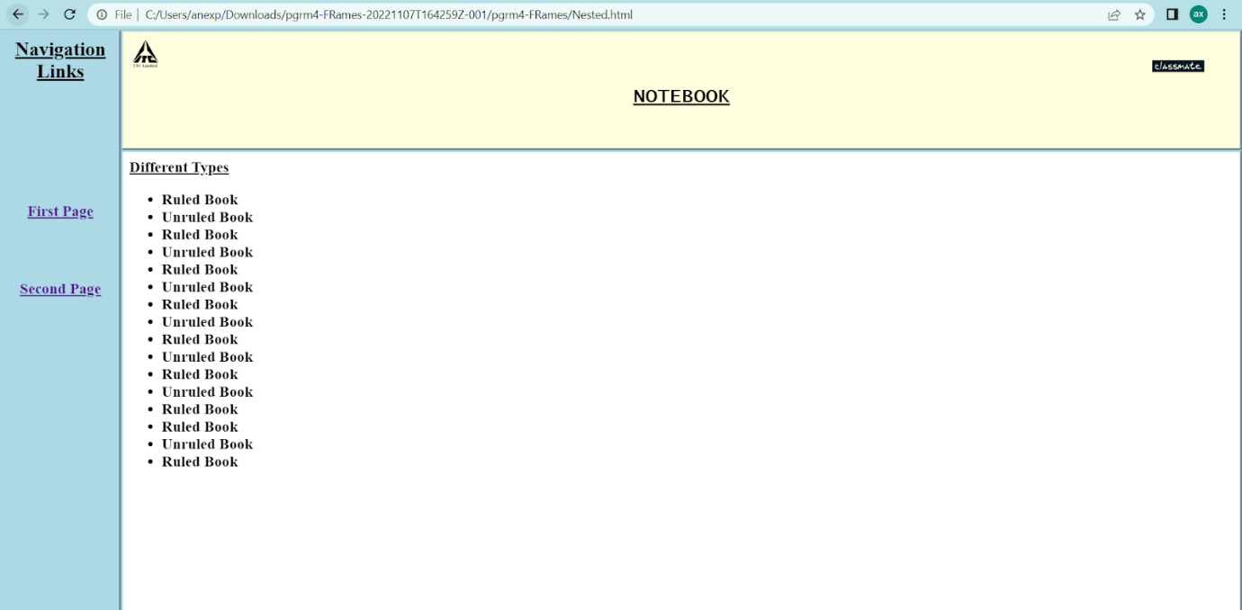

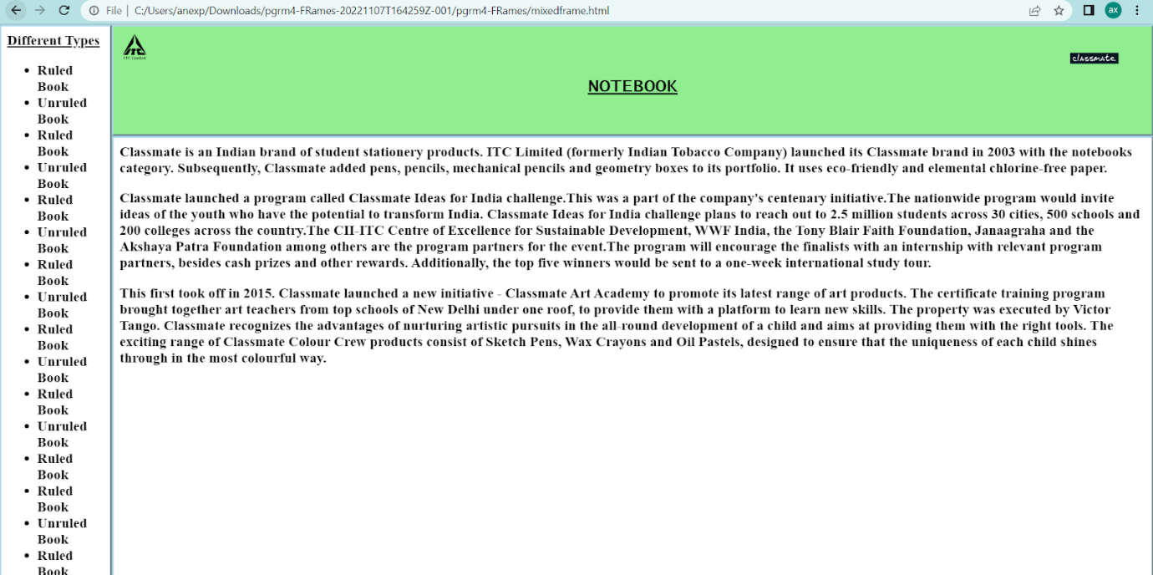

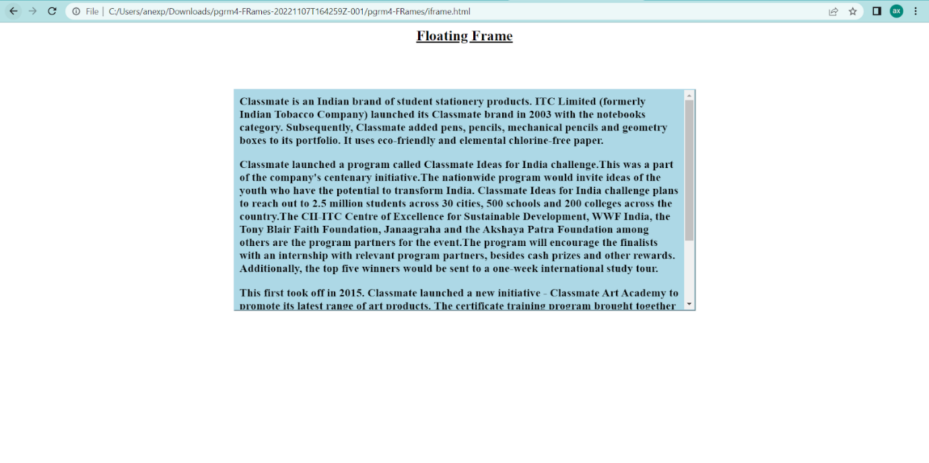

**AIM**

Analyse CSS by applying the different styles using inline, external & internal style sheets in a HTML file.

**Program Code**

**CODE - css.html**

<html>

<head>

<title>

</title>

<style>

.myDiv{

   width: 694px;

   height: 100px;

   position: absolute;

   top: 40%;

   left: 0%;

   background-color: lightblue;

   text-align: center;

   border-style: dotted;

   }

.myDiv1{

   width: 700px;

   height: 700px;

   position: absolute;

   top: 10%;

   left: 30%;

   background-color: lightgreen;

   text-align: center;

}

</style>

<link rel="stylesheet" href="style1.css">

</head>

<body background="/home/stud/public_html/Anex html/pgrm1/back.jpg">

<div class="myDiv1">

<br><br><h1><u>DIFFERENT CSS STYLES</u></h1><br><br><br>

<div class="myDiv">

<h3><br>This section has a internal css style.</h3>

</div>

<h3 style="color:red;font-size:24px;">This line has a inline css style.</h3>

<h3 class="he"><br><br>This section has a external css style.</h3>

</div>

</body>

</html>

**CODE - style.css**

h3.he{

   width: 700px;

   height: 100px;

   position: absolute;

   top: 60%;

   left: 0%;

   background-color: lightyellow;

   text-align: center;

   }

**Output**

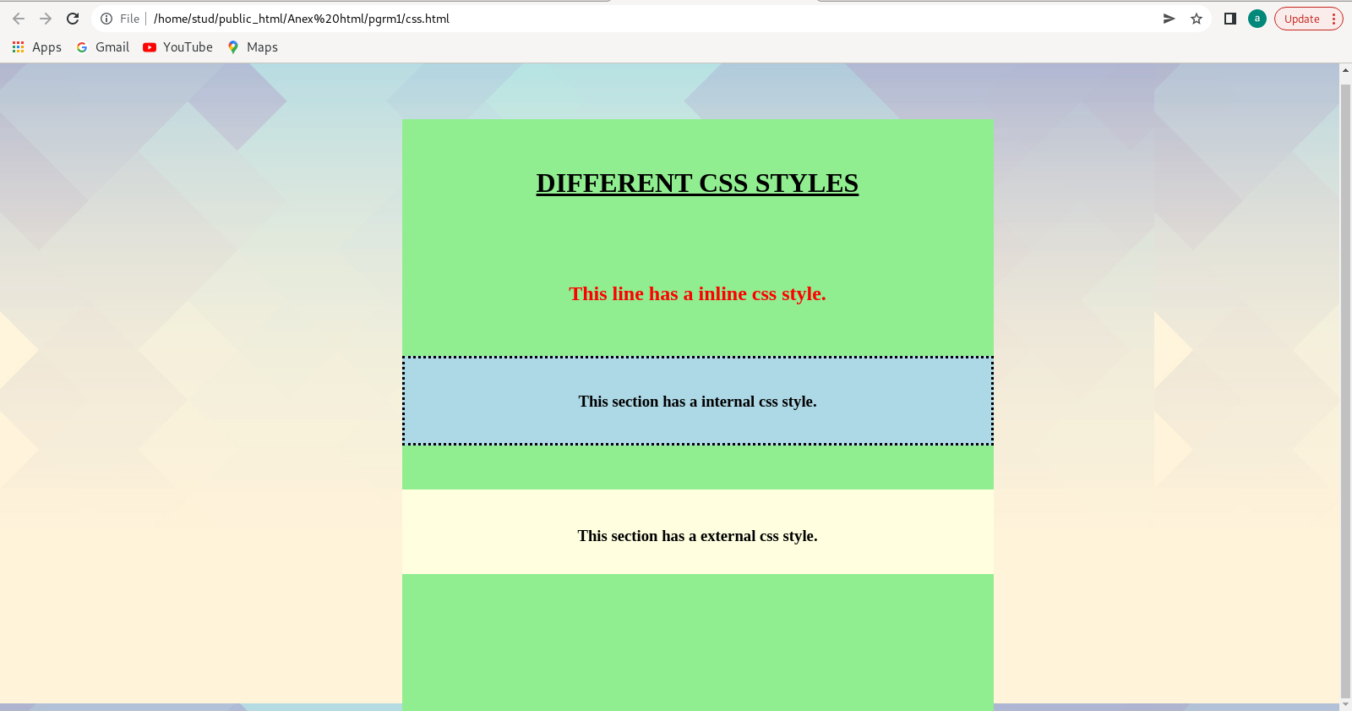

**AIM**

Compose Electricity bill from user input based on a given tariff using PHP.

**Program Code**

<html>

<head>

<title></title>

<script>

</script>

</head>

<body>

<?php

$amount = '';

$kwh_usage = '';

if (isset($_POST['submit'])) {

$units = $_POST['kwh'];

if (!empty($units)) {

$kwh_usage = calculate_electricity_bill($units);

$amount = '<strong>Total amount of ' . $units . ' units -</strong> ' . $kwh_usage;

}

}

function calculate_electricity_bill($units) {

$first_unit_cost = 8;

$second_unit_cost = 12;

$third_unit_cost = 16;

$fourth_unit_cost = 20;

if($units <= 100) {

$bill = $units * $first_unit_cost;

}

else if($units > 100 && $units <= 200) {

$temp = 100 * $first_unit_cost;

$remaining_units = $units - 100;

$bill = $temp + ($remaining_units * $second_unit_cost);

}

else if($units > 200 && $units <= 300) {

$temp = (100 * $first_unit_cost) + (100 * $second_unit_cost);

$remaining_units = $units - 200;

$bill = $temp + ($remaining_units * $third_unit_cost);

}

else {

$temp = (100 * $first_unit_cost) + (100 * $second_unit_cost) + (100 * $third_unit_cost);

$remaining_units = $units - 300;

$bill = $temp + ($remaining_units * $fourth_unit_cost);

}

return number_format((float)$bill, 2, '.', '');

}

?>

<div class="container">

<h1>Calculate electricity bill in PHP</h1>

<div class="form-group">

<form action="" method="post">

<div class="form-group">

<input type="number" name="kwh" placeholder="Please enter no. of Units" class="form-control" />

</div>

<div class="form-group">

<input type="submit" name="submit" class="btn btn-primary" value="Submit" />

</div></form></div>

<div>

<?php echo '<br />' . $amount; ?></div></div>

</body>

</html>

**Output**

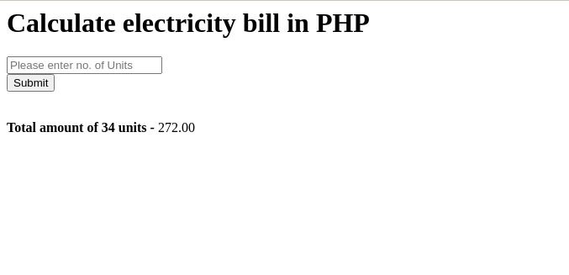

**AIM**

Build a PHP code to store name of students in an array and display it using print_r  
function. Sort and Display the same using assort & arsort functions.

**Program Code**

<html>

<head>

<title></title>

<link rel="stylesheet" href="style.css">

</head>

<body>

<?php error_reporting(0); ?>

<?php

$s1="";

$s2="";

$s3="";

$s4="";

$s5="";

$na1 = $_POST['s1'];

$na2 = $_POST['s2'];

$na3 = $_POST['s3'];

$na4 = $_POST['s4'];

$na5 = $_POST['s5'];

if (isset($_POST['submit'])) {

$dec = "";

$acend = "";

$n1 = array("Stud_1"=>"$na1","Stud_2"=>"$na2","Stud_3"=>"$na3","Stud_4"=>"$na4","Stud_5"=>"$na5");

$acend = '<strong>The Array in Ascending order is : ';

$dec = '<strong>The Array in Decending order is : ';

}

?>

<div class="form">

<h1>Store Name of Students</h1>

<form action="" method="post">

<input type="text" class="input" name="s1" placeholder="Please enter the name of student"/>

<br><br>

<input type="text" class="input" name="s2" placeholder="Please enter the name of student"/>

<br><br>

<input type="text" class="input" name="s3" placeholder="Please enter the name of student"/>

<br><br>

<input type="text" class="input" name="s4" placeholder="Please enter the name of student"/>

<br><br>

<input type="text" class="input" name="s5" placeholder="Please enter the name of student"/>

<br><br>

<input type="submit" name="submit" class="submit" value="Submit" />

</form>

<?php

echo "<br>";

echo "<br>";

echo  '<br/>'.$acend;

asort($n1);

print_r($n1);

echo "<br>";

echo "<br>";

echo "<br>";

echo '<br/>'.$dec;

arsort($n1);

print_r($n1);

echo "<br>";

?>

</div>

</body>

</html>

**Output**

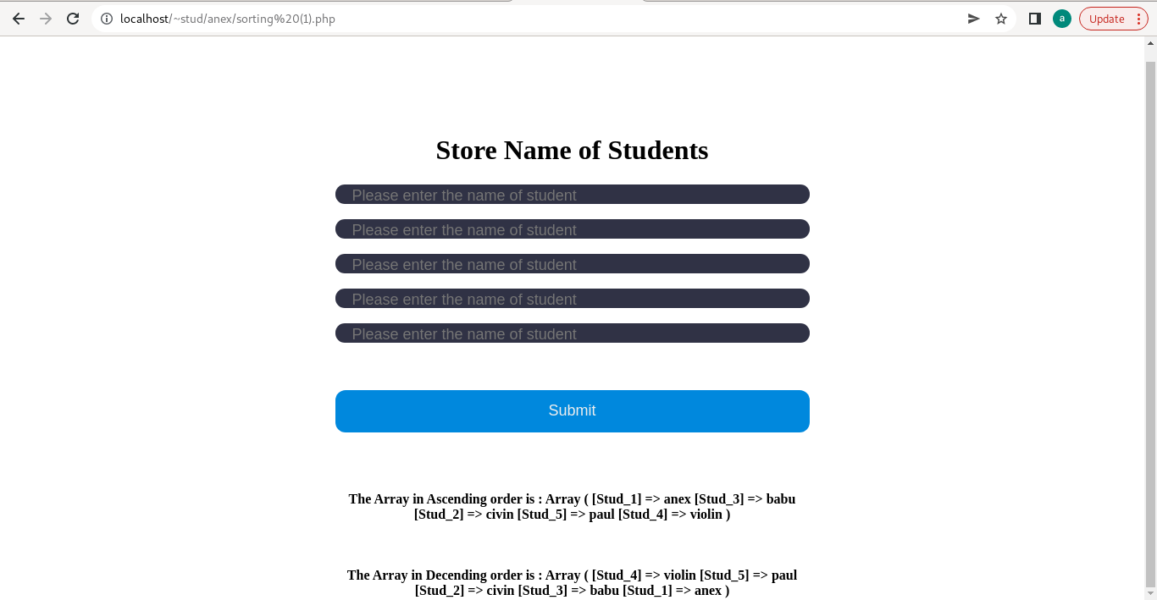

**AIM**

Build a PHP code to store name of Indian Cricket players in an array and display  
the same in HTML table.

**Program Code**

**Main.Php**

<html>

<head>

<title></title>

<link rel="stylesheet" href="style.css">

</head>

<body>

<?php error_reporting(0); ?>

<div class="form">

<h1><u>India Cricket Team Players</u></h1>

<form action="player.php" method="post">

<h3>Player 1</h3>

<input type="text" class="input" name="s1" placeholder="Please Enter the Player Name"/>

<br><br>

<select name="r1" class="select">

<option selected>Select Any Role</option>

<option>Wicket-Keeper</option>

<option>Batter</option>

<option>Bowler</option>

<option>All-Rounder</option>

</select>

<br>

<h3>Player 2</h3>

<input type="text" class="input" name="s2" placeholder="Please Enter the Player Name"/>

<br><br>

<select name="r2" class="select">

<option selected>Select Any Role</option>

<option>Wicket-Keeper</option>

<option>Batter</option>

<option>Bowler</option>

<option>All-Rounder</option>

</select>

<br>

<h3>Player 3</h3>

<input type="text" class="input" name="s3" placeholder="Please Enter the Player Name"/>

<br><br>

<select name="r3" class="select">

<option selected>Select Any Role</option>

<option>Wicket-Keeper</option>

<option>Batter</option>

<option>Bowler</option>

<option>All-Rounder</option>

</select>

<br>

<h3>Player 4</h3>

<input type="text" class="input" name="s4" placeholder="Please Enter the Player Name"/>

<br><br>

<select name="r4" class="select">

<option selected>Select Any Role</option>

<option>Wicket-Keeper</option>

<option>Batter</option>

<option>Bowler</option>

<option>All-Rounder</option>

</select>

<br>

<h3>Player 5</h3>

<input type="text" class="input" name="s5" placeholder="Please Enter the Player Name"/>

<br><br>

<select name="r5" class="select">

<option selected>Select Any Role</option>

<option>Wicket-Keeper</option>

<option>Batter</option>

<option>Bowler</option>

<option>All-Rounder</option>

</select>

<br><br>

<input type="submit" name="submit" class="submit" value="Submit" />

</form>

</div>

</body>

</html>

**Player.php**

<html>

<head>

<title></title>

<link rel="stylesheet" href="table.css">

</head>

<body>

<?php error_reporting(0); ?>

<?php

$na1 = $_POST['s1'];

$na2 = $_POST['s2'];

$na3 = $_POST['s3'];

$na4 = $_POST['s4'];

$na5 = $_POST['s5'];

$na6 = $_POST['r1'];

$na7 = $_POST['r2'];

$na8 = $_POST['r3'];

$na9 = $_POST['r4'];

$na10 = $_POST['r5'];

if (isset($_POST['submit'])) {

$n1 = array("Player 1"=>"$na1","Player 2"=>"$na2","Player 3"=>"$na3","Player 4"=>"$na4","Player 5"=>"$na5");

$n2 = array("Player 1"=>"$na6","Player 2"=>"$na7","Player 3"=>"$na8","Player 4"=>"$na9","Player 5"=>"$na10");

}

?>

<section>

<h1><u>India Cricket Team Players</u></h1>

<div class="tbl-header">

<table cellpadding="0" cellspacing="0" border="0">

<tr>

<th>SI.No.</th>

<th>Player Name</th>

<th>Role</th>

<th>Country</th>

</tr>

</table>

</div>

<div class="tbl-content">

<table cellpadding="0" cellspacing="0" border="0">

<tr>

<td>1</td>

<td><?php echo $n1['Player 1'] ?></td>

<td><?php echo $n2['Player 1'] ?></td>

<td>Indian</td>

</tr>

<tr>

<td>2</td>

<td><?php echo $n1['Player 2'] ?></td>

<td><?php echo $n2['Player 2'] ?></td>

<td>Indian</td>

</tr>

<tr>

<td>3</td>

<td><?php echo $n1['Player 3'] ?></td>

<td><?php echo $n2['Player 3'] ?></td>

<td>Indian</td>

</tr>

<tr>

<td>4</td>

<td><?php echo $n1['Player 4'] ?></td>

<td><?php echo $n2['Player 4'] ?></td>

<td>Indian</td>

</tr>

<tr>

<td>5</td>

<td><?php echo $n1['Player 5'] ?></td>

<td><?php echo $n2['Player 5'] ?></td>

<td>Indian</td>

</tr>

</table>

</div>

</section>

</body>

</html>

**Output**

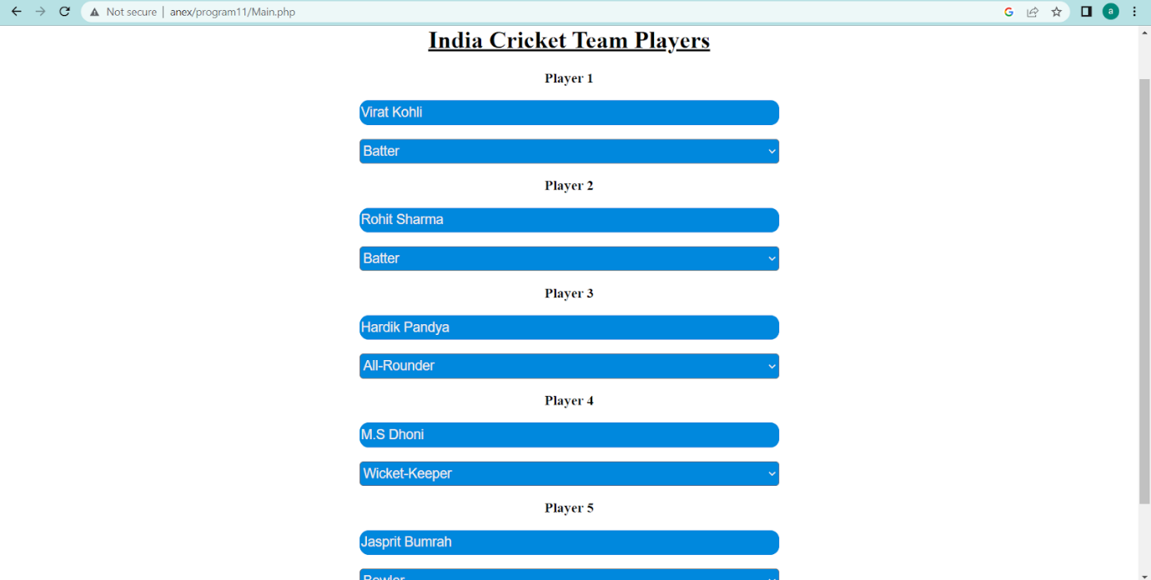

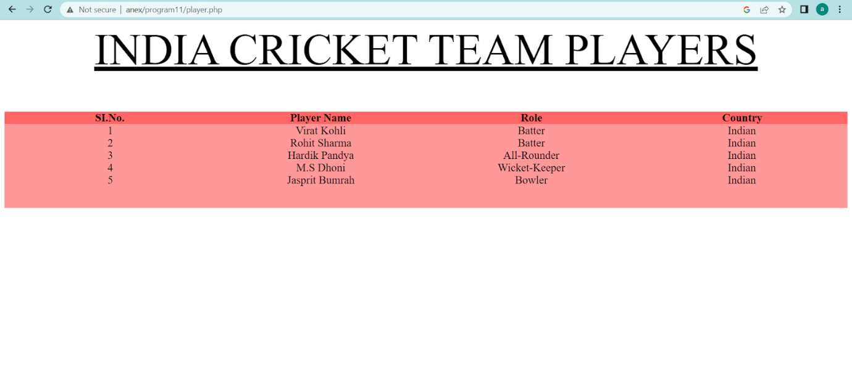

**AIM**

Outline a registration form using PHP and do necessary validations.

**Program Code**

<html>

<head>

<title>PHP Registration Form </title>

<link rel="stylesheet" href="style.css">

</head>

<body>

<?php error_reporting(0); ?>

<?php

$n1 = $_POST["fname"];

$n2 = $_POST["mob"];

$n3 = $_POST["email"];

$n4 = $_POST["dob"];

$n5 = $_POST["Gend"];

$x = $_POST["pass"];

$y = $_POST["cpass"];

if (isset($_POST["submit"]))

{

  if (empty($_POST["fname"])) {

    $mess1 = "*Name is required";

  }

if (empty($_POST["mob"])) {

    $mess2 = "*Mobile No is required";

  }

if (is_numeric($_POST["mob"])) {

$mess8 = "Mobile No is digits only";

}

else {

    $mess9 = "*Mobile No should have digits only";

}

if (empty($_POST["email"])) {

    $mess3 = "*Email is required";

  }

if (empty($_POST["pass"])) {

    $mess4 = "*Password is required";

  }

if (empty($_POST["cpass"])) {

    $mess5 = "*Password is required";

}

if (empty($_POST["Gend"])) {

    $mess6 = "*Gender is required";

  }

if ($x!=$y) {

    $mess7 = "*Password entered are not same";

  }

if ( $n1 != NULL && $n2 != NULL && $n3 != NULL && $n4 != NULL && $n5 != NULL && $x != NULL && $y != NULL)

{

$mess10 = "User Details saved successfully, Please log in to continue.";

}

}

?>

<div class="container">

<div class="title">Registration</div>

<div class="content">

<form name="myForm" method="post" action="">

<div class="user-details">

<div class="input-box">

Name:<p style="font-size:15px;color:red;"><?php echo $mess1;?></p>

<input type="text" placeholder="Name of the student" name="fname" value="<?php echo $n1; ?>">

</div>

<div class="input-box">

Date of Birth: <input type="date" placeholder="DOB of student" name="dob" value="<?php echo $n4; ?>">

</div>

<div class="input-box">

Mobile Number:<p style="font-size:15px;color:red;"><?php echo $mess2;?></p>

<input type="text" placeholder="Phone no of the student" name="mob" value="<?php echo $n2; ?>">

<p style="font-size:15px;color:red;"><?php echo $mess9;?></p>

</div>

<div class="input-box">

Email Id:<p style="font-size:15px;color:red;"><?php echo $mess3;?></p>

<input type="email" pattern=".+@gmail\.com" placeholder="Email id of the student" name="email" value="<?php echo $n3; ?>">

</div>

<div class="input-box">

Password:<p style="font-size:15px;color:red;"><?php echo $mess4;?></p>

<input type="password" placeholder="Enter your password" name="pass" value="<?php echo $x; ?>">

</div>

<div class="input-box">

Confirm Password:<p style="font-size:15px;color:red;"><?php echo $mess5;?></p>

<input type="password" placeholder="Confirm your password" name="cpass" value="<?php echo $y; ?>">

<p style="font-size:15px;color:red;"><?php echo $mess7;?></p>

</div>

<div class="gender-details">

Gender:

<p style="font-size:15px;color:red;"><?php echo $mess6;?></p>

<div class="category">

Male <input type="radio" name="Gend" <?php if ($n5=="male") echo "checked";?> value="male">

Female <input type="radio" name="Gend" <?php if ($n5=="female") echo "checked";?> value="female">

</div>

</div>

<div class="category">

<div class="button">

<input type="submit" name="submit" value="Register">

<br>

<br>

<input type="reset" name="reset" value="Reset">

</div>

</div>

</form>

</div>

</div>

<div class="d1">

<h2><p style="font-size:15px;"><?php echo $mess10;?></p></h2>

</div>

</body>

</html>

**Output**

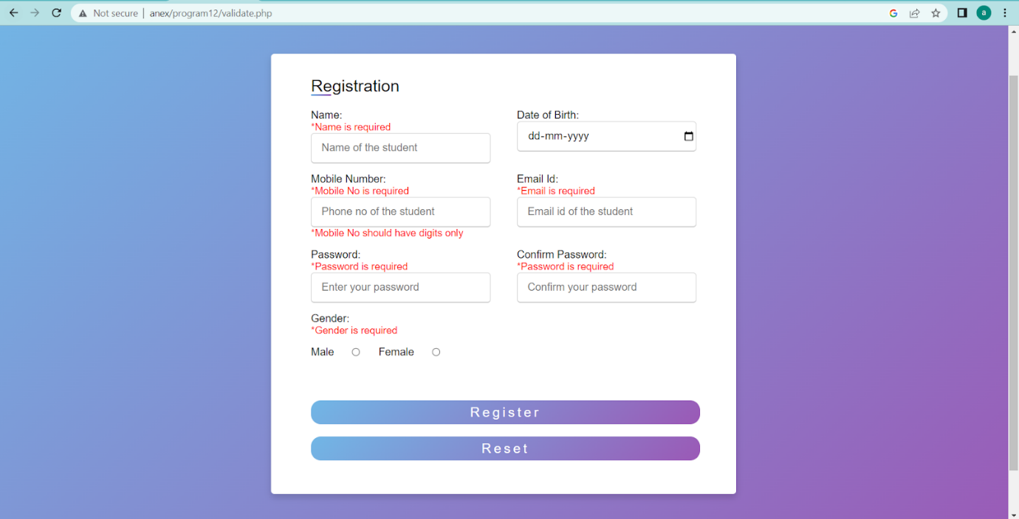

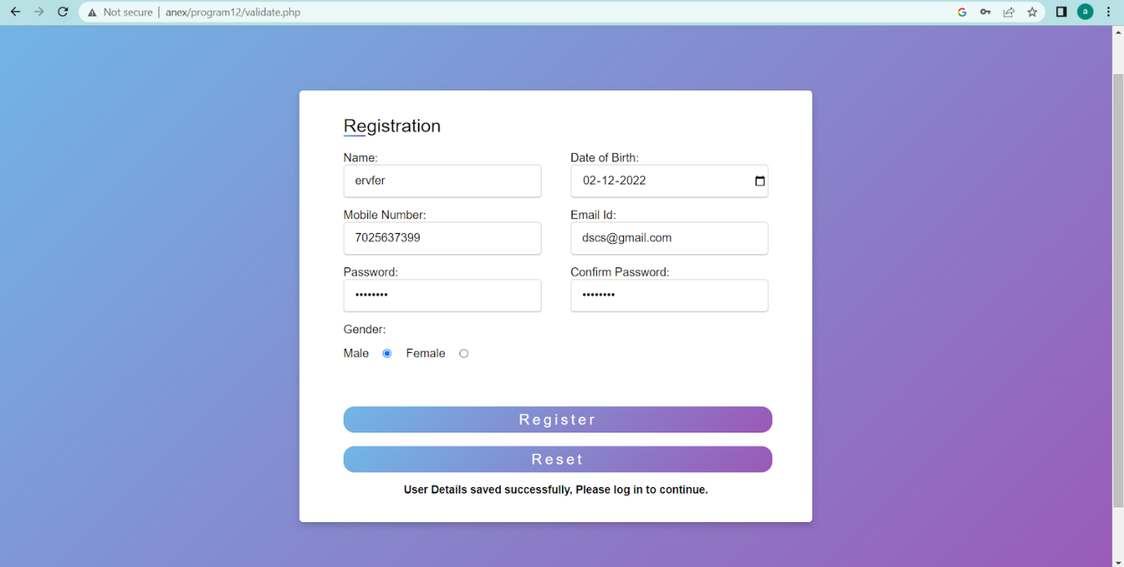

**AIM**

Develop a PHP program to connect to a database and add data to the employee table and retrieve data from the table and  
show the retrieved details in a neat format.

**Program Code**

**Main.php**

<html>

<head>

<title>Employee Form </title>

<link rel=”stylesheet” href=”style.css”>

</head>

<body>

<?php error_reporting(0);?>

<div class=”container”>

<div class=”title”>HOMEPAGE</div>

<div class=”content”>

<form name=”myForm” method=”post” action=”table.php”>

<div class=”user-details”>

<div class=”category”>

<div class=”button”>

<input type=”submit” name=”submit” value=”DATA”>

</form>

</div>

</div>

</div>

<form name=”myForm1” method=”post” action=”connect.php”>

<div class=”user-details”>

<div class=”category”>

<div class=”button”>

<input type=”submit” name=”submit1” value=”INSERT”>

</form>

<div class=”d1”>

<br><br>

<h2><p style=”font-size:15px;”><?php echo $msg1;?></p></h2>

</div>

</div>

</body>

</html>

**Connect.php**

<html>

<head>

<title>Employee Form </title>

<link rel=”stylesheet” href=”style.css”>

</head>

<body>

<?php error_reporting(0); ?>

<?php

$n1 = $_POST[“eid”];

$n2 = $_POST[“ename”];

$n3 = $_POST[“edpart”];

$n4 = $_POST[“eage”];

If (isset($_POST[“submit”]))

{

$servername = “localhost”;

$username = “fisat”;

$password = “fisat”;

// Create connection

$conn = new mysqli($servername, $username, $password,”fisatdb”);

// Check connection

If ($conn->connect_error) {

  Die(“Connection failed: “ . $conn->connect_error);

}

$msg = “Connected successfully”;

$sql = “INSERT INTO employee(empID,empName,Dept,Age) VALUES($n1,’$n2’,’$n3’,$n4)”;

If ($conn->query($sql) === true) {

$msg1 = ‘New row added.’;

} else {

Echo “ERROR: Could not execute query:”;

}

$conn->close();

}

?>

<div class=”container”>

<div class=”title”>Registration</div>

<div class=”content”>

<form name=”myForm” method=”post” action=””>

<div class=”user-details”>

<div class=”input-box”>

EmpId:<p style=”font-size:15px;color:red;”></p>

<input type=”number” placeholder=”ID of the employee” name=”eid”>

</div>

<div class=”input-box”>

EmpName: <input type=”text” placeholder=”Employee name” name=”ename”>

</div>

<div class=”input-box”>

Department:<p style=”font-size:15px;color:red;”></p>

<input type=”text” placeholder=”Phone no of the student” name=”edpart”>

</div>

<div class=”input-box”>

Age:<p style=”font-size:15px;color:red;”></p>

<input type=”number” placeholder=”Age of the employee” name=”eage”>

</div>

</div>

<div class=”category”>

<div class=”button”>

<input type=”submit” name=”submit” value=”Register”>

<br>

<br>

<input type=”reset” name=”reset” value=”Reset”>

</div>

</div>

</form>

</div>

<div class=”d1”>

<br><br>

<h2><p style=”font-size:15px;”><?php echo $msg1;?></p></h2>

</div>

</div>

</body>

</html>

**Table.php**

<?php

$con = new mysqli(“localhost”, “fisat”, “fisat”, “fisatdb”);

If ($con=== false) {

Die(“ERROR: Could not connect. “ . mysqli_connect_error());

}

$sql = “SELECT * FROM employee”;

If ($result = $con->query($sql))

{ if ($result->num_rows > 0) {

 ?>

<html>

<head>

<title>Employee Form </title>

<link rel=”stylesheet” href=”style.css”>

</head>

<body>

<div class=”container”>

<div class=”title”>DATA OF EMPLOYEES</div>

<br>

<br>

<div class=”content”>

<table border=1>

<tr>

<th>Employee ID</th><th>Employee Name</th><th>Employee Department</th><th>Employee Age</th>

</tr>

<tr>

<?php while($row = $result->fetch_array()) { ?>

<td><?php echo $row[0]; ?> </td><td><?php echo $row[1];?></td><td><?php echo $row[2];?></td><td><?php echo $row[3];?></td>

</tr>

<?php

} ?>

</table>

</div>

</div>

</div>

</body>

</html>

<?php

$result->close();

} else {

Echo “No records matching your query were found.”;

}

} else {

Echo “ERROR: Could not execute $sql. “ . $con->error;

} $con->close();

?>

**Output**

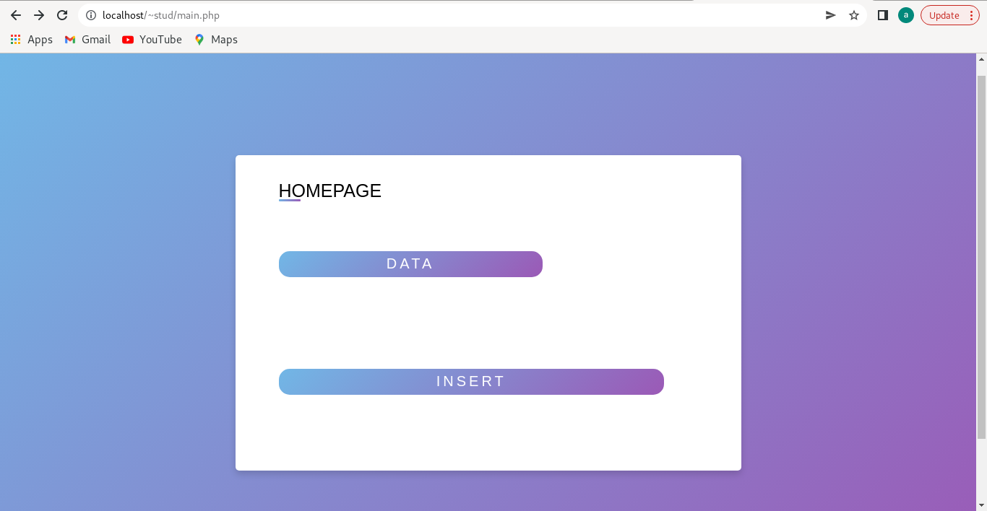

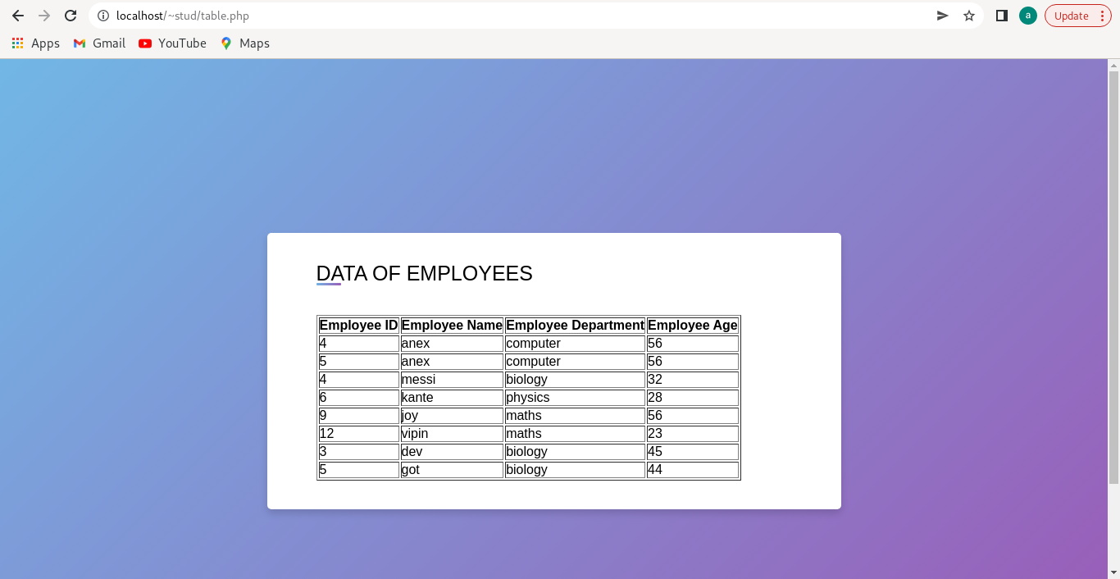

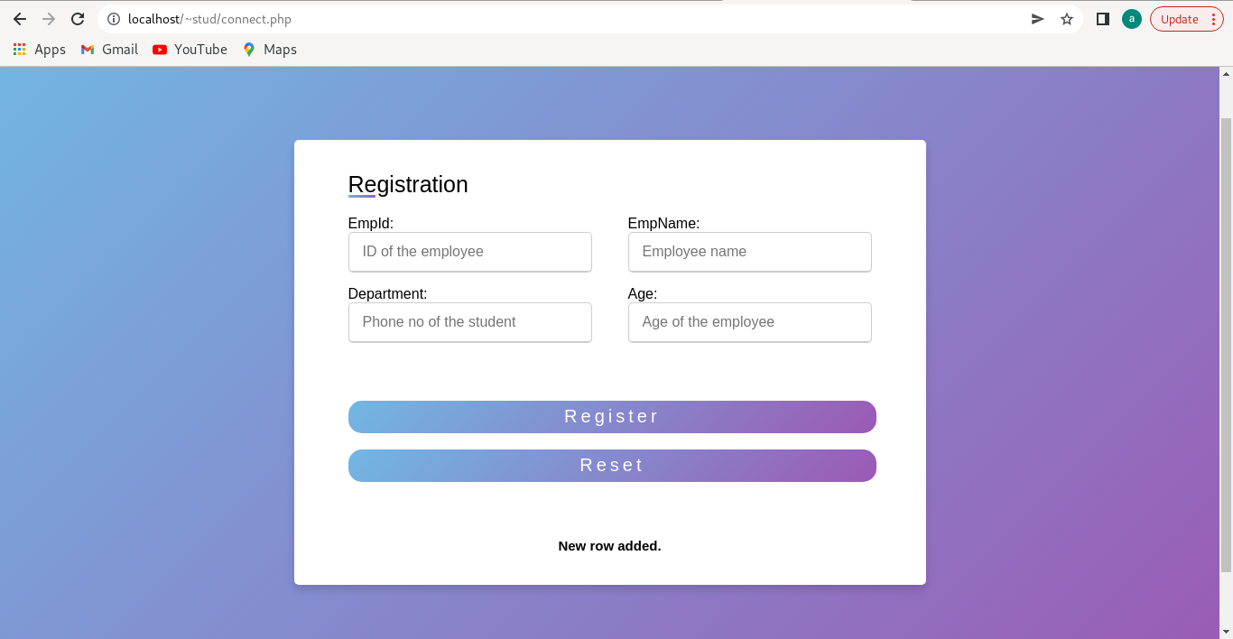

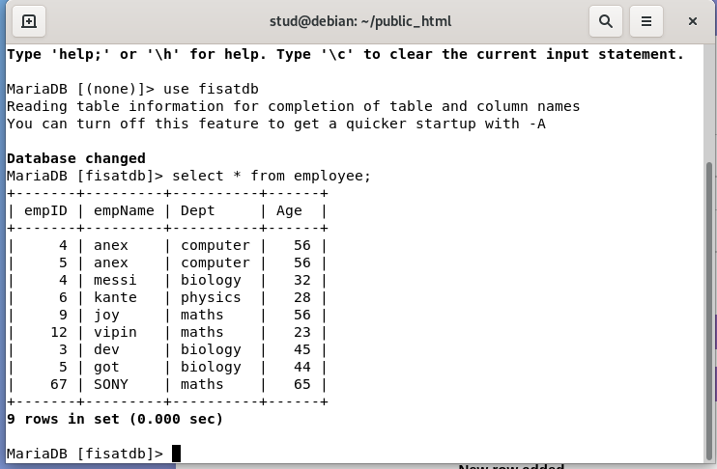

**AIM**

Using PHP and MySQL, develop a program to accept book information viz. Accession number, title, authors, edition and publisher from a web page and store the information in a database and to search for a book with the  
title specified by the user and to display the search results with proper headings.

**Program Code**

**Main.php**

<html>

<head>

<title>Employee Form </title>

<link rel="stylesheet" href="style.css">

</head>

<body>

<?php error_reporting(0);?>

<div class="container">

<div class="title">Book Details</div>

<div class="content">

<form name="myForm" method="post" action="tableform.php">

<div class="user-details">

<div class="category">

<div class="button">

<input type="submit" name="submit" value="Search">

</form>

</div>

</div>

</div>

<form name="myForm1" method="post" action="insert.php">

<div class="user-details">

<div class="category">

<div class="button">

<input type="submit" name="submit1" value="Add">

</form>

<div class="d1">

<br><br>

<h2><p style="font-size:15px;"><?php echo $msg1;?></p></h2>

</div>

</div>

</body>

</html>

**Insert.php**

<html>

<head>

<title>Book Registration</title>

<link rel="stylesheet" href="style.css">

</head>

<body>

<?php error_reporting(0); ?>

<?php

$n1 = $_POST["bid"];

$n2 = $_POST["btitle"];

$n3 = $_POST["bauthor"];

$n4 = $_POST["bedit"];

$n5 = $_POST["bpub"];

if (isset($_POST["submit"]))

{

$servername = "localhost";

$username = "root";

$password = "";

// Create connection

$conn = new mysqli($servername, $username, $password,"anex");

// Check connection

if ($conn->connect_error) {

  die("Connection failed: " . $conn->connect_error);

}

$msg = "Connected successfully";

$sql = "INSERT INTO books(acss_no,title,author,edition,publisher) VALUES($n1,'$n2','$n3',$n4,'$n5')";

if ($conn->query($sql) === true) {

$msg1 = 'New row added.';

} else {

echo "ERROR: Could not execute query:";

}

$conn->close();

}

?>

<div class="container">

<div class="title">Registration</div>

<div class="content">

<form name="myForm" method="post" action="">

<div class="user-details">

<div class="input-box">

Accession number:<p style="font-size:15px;color:red;"></p>

<input type="number" placeholder="ID of the Book" name="bid">

</div>

<div class="input-box">

Title:<input type="text" placeholder="Book Title" name="btitle">

</div>

<div class="input-box">

Author name:<p style="font-size:15px;color:red;"></p>

<input type="text" placeholder="Author name" name="bauthor">

</div>

<div class="input-box">

Edition:<p style="font-size:15px;color:red;"></p>

<input type="number" placeholder="Edition Number" name="bedit">

<div class="input-box">

Publisher:<p style="font-size:15px;color:red;"></p>

<input type="text" placeholder="Publisher Name" name="bpub">

</div>

</div>

<div class="category">

<div class="button">

<input type="submit" name="submit" value="&nbsp;&nbsp;&nbsp;&nbsp;Add">

<br>

<br>

<center>

<div class="ata">

<a href="main.php">

&nbsp;&nbsp;Home

</a>

</div>

</center>

</div>

</div>

</form>

</div>

<div class="d1">

<br><br>

<h2><p style="font-size:15px;"><?php echo $msg1;?></p></h2>

</div>

</div>

</body>

</html>

**Tableform.php**

<html>

<head>

<title>Search Page</title>

<link rel="stylesheet" href="style.css">

</head>

<body>

<?php error_reporting(0);?>

<div class="container">

<div class="title">Search Books and display results</div>

<div class="content">

<form action="table.php" method="post">

<br/><br/>

<div class="user-details">

<div class="input-box">

Search Employee Information:<p style="font-size:15px;color:red;"></p>

<input type="text" name="search" placeholder="search here">

</div>

</div>

<div class="category">

<div class="button">

<input type="submit" name="save" value="Search">

<br>

<br>

<center>

<div class="ata">

<a href="main.php">

&nbsp;&nbsp;Home

</a>

</div>

</center>

</div>

</div>

</div>

</form>

</div>

<div class="d1">

<br><br>

<span class="error" style="color:red;"> <?php echo $searchErr;?></span>

<br><br>

<span class="error" style="color:red;"> <?php echo $emp;?></span>

</div>

</div>

</div>

</div>

</body>

</html>

**Table.php**

<?php error_reporting(0); ?>

<?php

$searchErr = '';

$book_details='';

if(isset($_POST["save"]))

{

$con = new mysqli("localhost", "root", "", "anex");

if ($con=== false) {

die("ERROR: Could not connect. " . mysqli_connect_error());

}

if(!empty($_POST["search"]))

{

$search = $_POST["search"];

$sql = "select * from books where title like '%$search%'";

$book_details = $con->query($sql);

}

else

{

$searchErr = "Please enter the information";

}

}

?>

<html>

<head>

<title>Search Page</title>

<link rel="stylesheet" href="style.css">

</head>

<body>

<?php

?>

<div class="container">

<div class="title">Search Result</div>

<br>

<br>

<div class="content">

<table align="center" border="1" class="table">

<thead>

<?php

if($book_details->num_rows == 0)

{

echo "No records";

}

else

{

?>

 <tr>

<th>Accession Number</th>

<th>Title</th>

<th>Author Name</th>

<th>Edition Number</th>

<th>Publisher Name</th>

</tr>

</thead>

<tbody>

<tr>

<?php

foreach($book_details as $key=>$value)

{

?>

<td><?php echo $value['acss_no'];?></td>

<td><?php echo $value['title'];?></td>

<td><?php echo $value['author'];?></td>

<td><?php echo $value['edition'];?></td>

<td><?php echo $value['publisher'];?></td>

</tr>

<?php

}

}

$con->close();

?>

</tbody>

</table>

</div>

</div>

</div>

</div>

</div>

<br/><br/>

</body>

</html>

**Output**

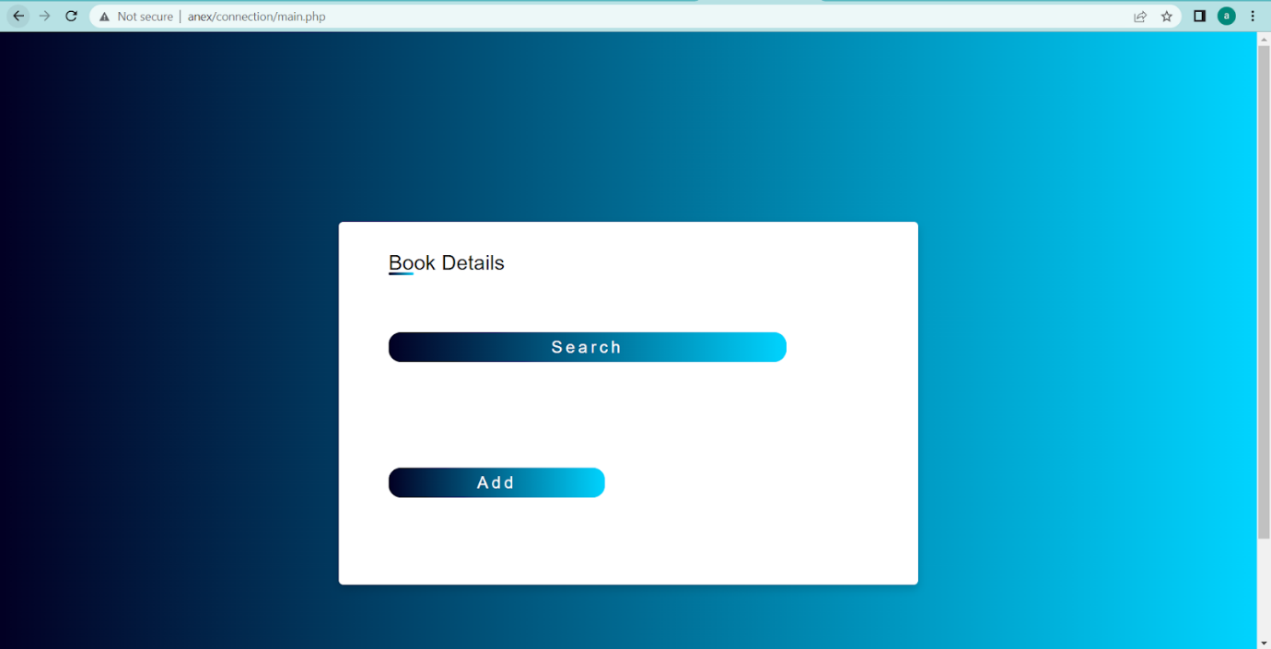

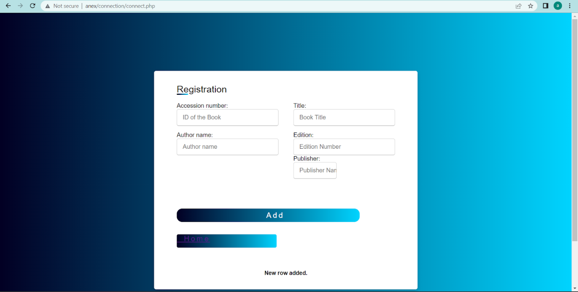

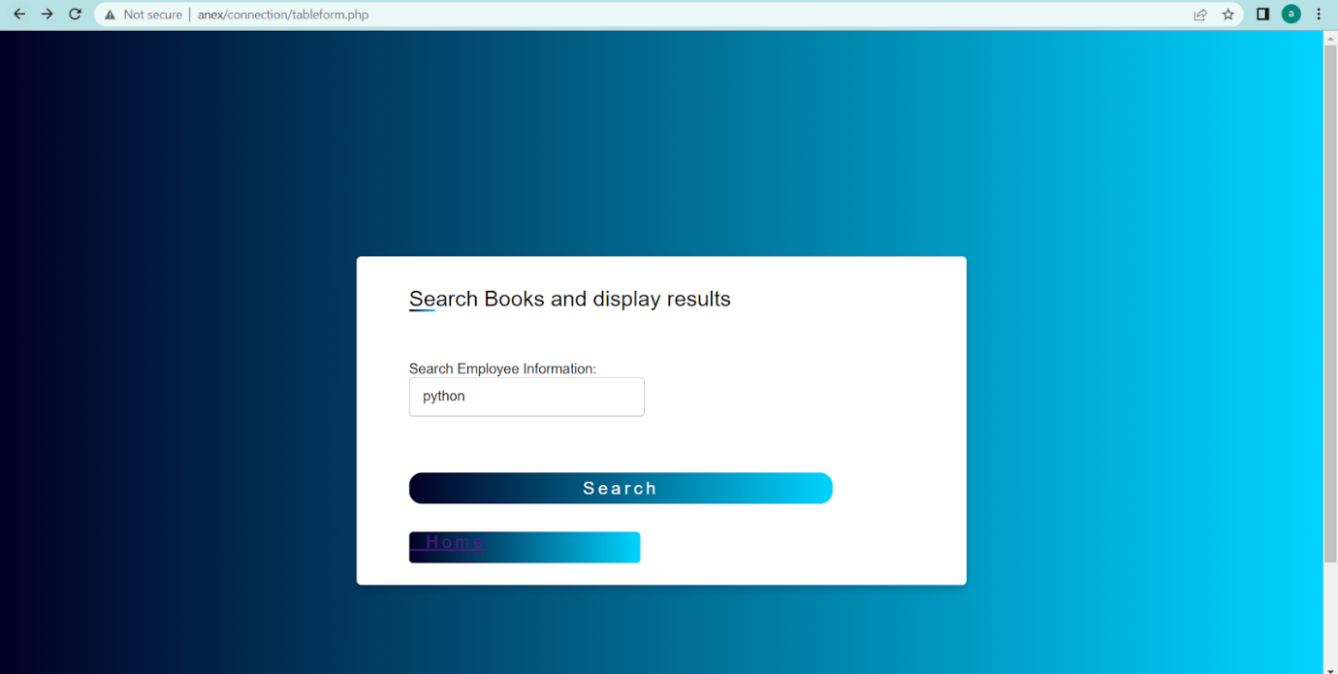

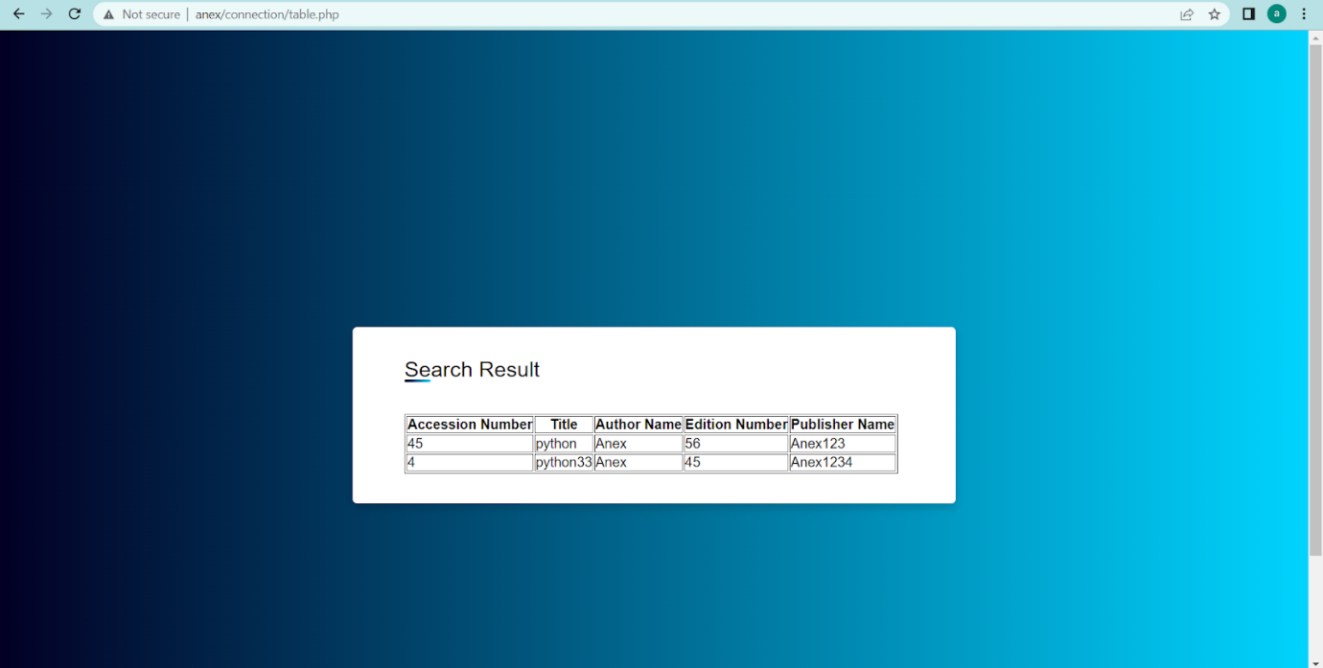

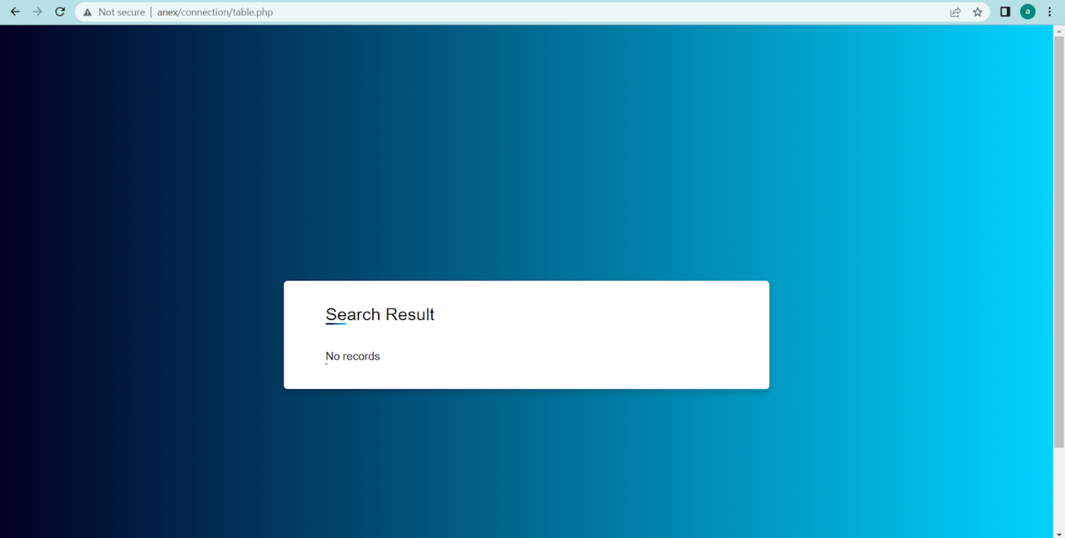

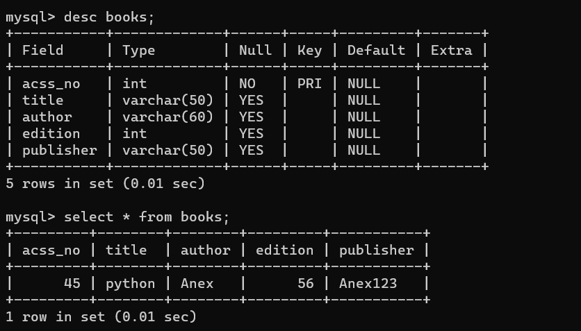

**AIM**

Using PHP and MySQL, develop a program to collect airline details and display all the airlines between a particular source and destination.

**Program Code**

**Airline.html**

<html>

<head>

<title>airline</title>

</head>

<body align="center"><u>AIRLINE INFORMATION SYSTEM</u><br>

<a href="airlineinfo.html">Add AIRLINE DETAILS</a><br>

<a href="search.html">Search AIRLINE DETAILS</a><br>

</body>

</html>

**airlineinfo.html**

<html><head>

<title>add airline</title></head>

<body>

<form name="frm1" action="addairline.php" method="POST">

<center><b><u>Enter Airline Details</u></b><br>

AIRLINE ID:<input type="number" name="id"><br>

AIRLINE NAME:<input type="text" name="name"><br>

DEPARTURE FROM:<input type="text" name="depfrom"><br>

DEPARTURE TIME:<input type="number" name="deptime"><br>

AIRIVAL TIME:<input type="number" name="aritime"><br>

AIRIVAL PLACE:<input type="text" name="ariplace"><br>

<input type="submit" name="Submit">

<input type="reset" name=“Reset">

</form>

</body>

</html>

**addairline.php**

<?php

$id=$_POST['id'];

$name=$_POST['name'];

$depfrom=$_POST['depfrom'];

$deptime=$_POST['deptime'];

$airtime=$_POST['aritime'];

$airplace=$_POST['ariplace'];

$con=new mysqli("localhost","fisat","fisat","fisatdb");

if($con==false)

{

echo "Failed to connect";

}

else

{

echo "connected";

}

$sql="INSERT INTO airline VALUES($id,'$name','$depfrom',$deptime,$airtime,'$airplace')";

if($con->query($sql))

{

echo "<BR>";

echo 'New row added';

}

else

{

echo "ERROR:could not execute query";

}

$con->close();

?>

**search.html**

<html>

<head>

<title>search</title>

</head>

<body>

<form name="frm2" action="search.php"method="POST">

<center>

<b><u>SEARCH AIRLINE</u></b><br>

DEPARTURE FROM:<input type="text" name="txt"><br>

ARIVAL PLACE:<input type="text" name="txt1"><br>

<input type="submit" name="Submit">

</center>

</form>

</body>

</html>

**search.php**

<?php

$depfrom=$_POST['txt'];

$ariplace=$_POST['txt1'];

$con=new mysqli("localhost","fisat","fisat","fisatdb");

if($con==false)

{

echo "Failed to connect";

}

else

{

echo "";

}

$sql="select * from airline where deptfrom = '$depfrom' and airplace = '$ariplace' ";

?>

<div align="center">

<br><br><br>

<div class="title"><strong><u>Search Result</u></strong></div>

<br><br><br>

<table align="center" border="1" class="table">

<thead>

<tr>

<th>ID</th>

<th>Name</th>

<th>DeptFrom</th>

<th>DeptTime</th>

<th>AirTime</th>

<th>AirPlace</th>

</tr>

<?php

if($result=$con->query($sql))

{

if($result->num_rows>0)

{

while($row=$result->fetch_array())

{?>

<td><?php echo $row[0]; ?> </td>

<td><?php echo $row[1]; ?> </td>

<td><?php echo $row[2]; ?> </td>

<td><?php echo $row[3]; ?> </td>

<td><?php echo $row[4]; ?> </td>

<td><?php echo $row[5]; ?> </td>

<?php

}

$result->close();

}

else

{

echo "\nCould not found the airline";

}

}

else

{

echo "\nError:could not connect";

}

$con->close();

?>

**Output**

